CS 255 System Design Document Template

This template lays out all the different sections that you need to complete for Project Two. Each section has guidance to prompt your thinking. You will need to continually reference the interview transcript as you work to make sure that you are addressing your client’s needs. There is no required length for the final document. Instead the goal is to complete each section based on what your client’s needs are. Remove this note when you are finished, and replace all bracketed text with the relevant information.

UML Diagrams

UML Use Case Diagram
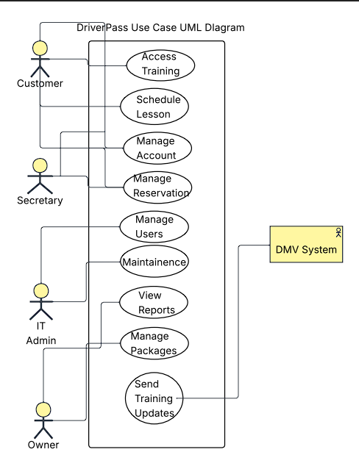

UML Activity Diagrams

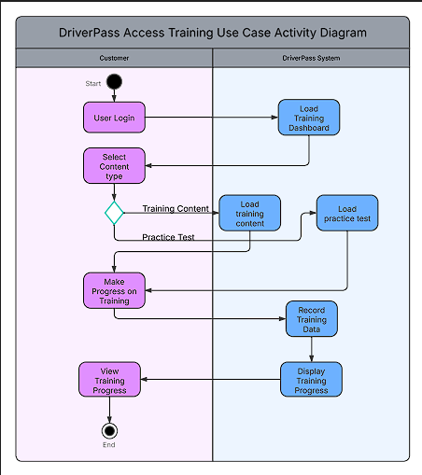

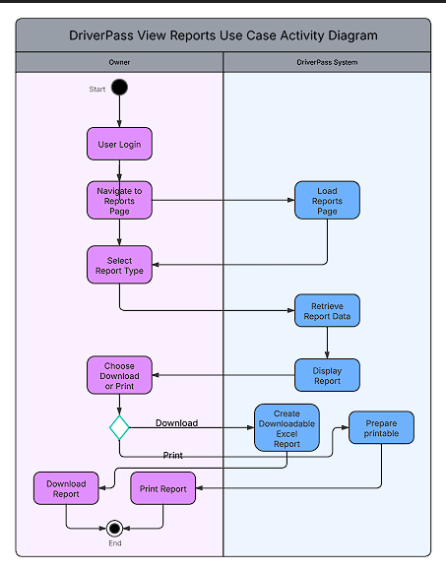

UML Sequence Diagram
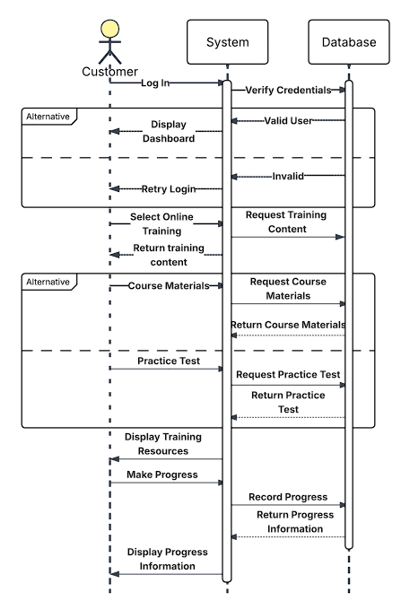

UML Class Diagram
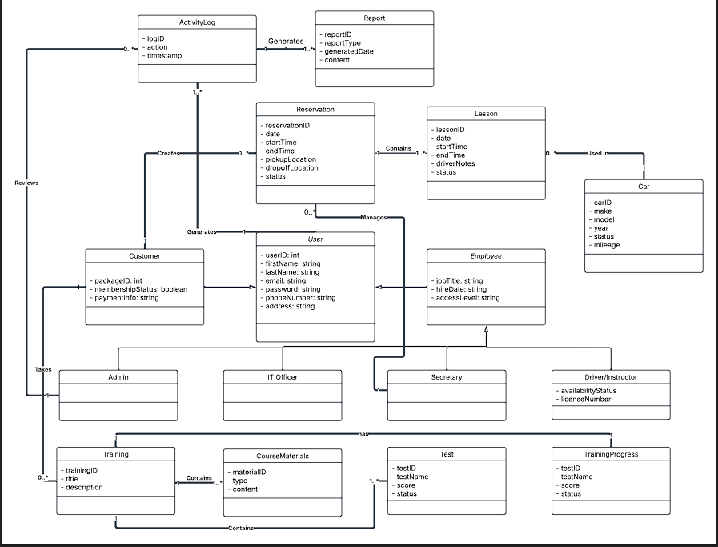

Technical Requirements
Hardware Requirements:
- Client Devices (desktop, laptop, tablet, or smartphone) so that users can access the web application.
- Storage systems for data and backups
- Cloud Storage so that reports can be accessed from anywhere.

Software Requirements:
- Web Browser (Edge, Chrome, Safari, Firefox)
- Backend Software (Django, Node.js, SpringBoot)
- Database System (MySQL, PostgreSQL)

Tools:
- Development tools (IDEs)
- Database Management tools
- Cloud Management Tools for monitoring and maintaining the system

Infrastructure:
- Cloud hosting environment to make sure the system is maintainable, scalable, and able to be accessed 24/7.
- Internet activity for user access
- A secure network configuration to protect sensitive information.

